Borrowers: Mr. Chea Yi and Mdm. Ting Bopha
Conducted by Mr. Chiv Hak and Ms. Taing Chandavy on 13-06-2016

Property charged 1: A parcel of land accommodating a 2 storey shop house.
Address: No. 391, National Road No. 1, Toul Thnout Village, Korki Commune, Kean Svay District, Kandal Province.

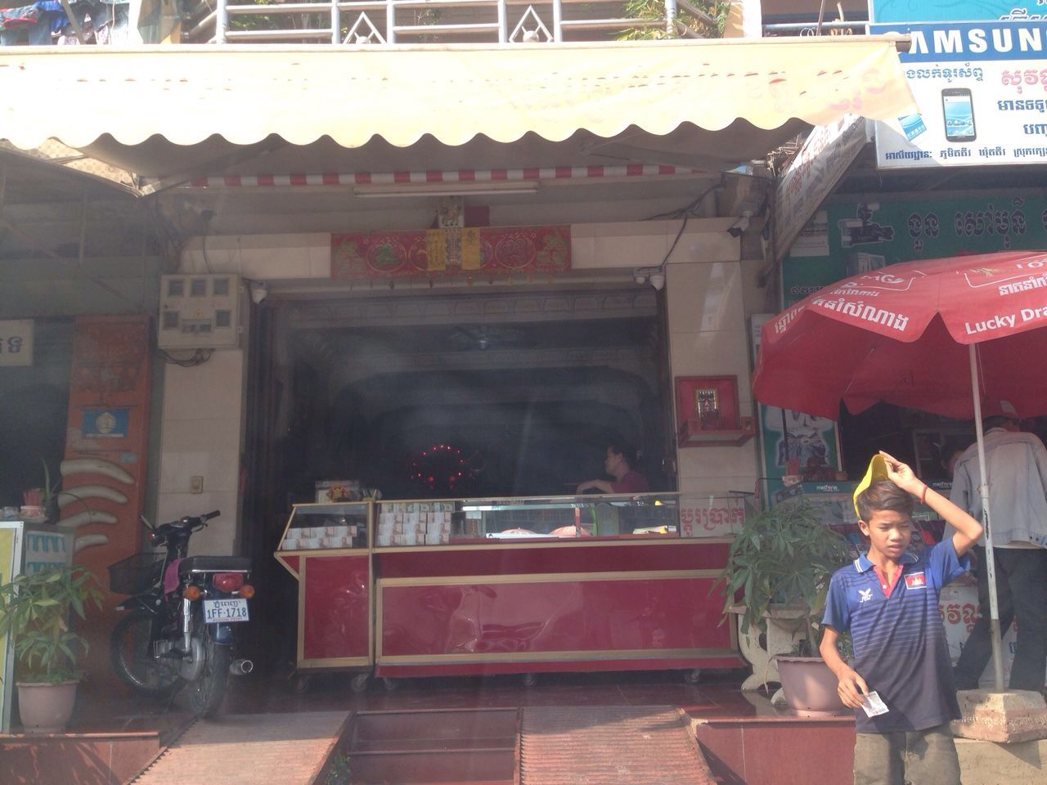
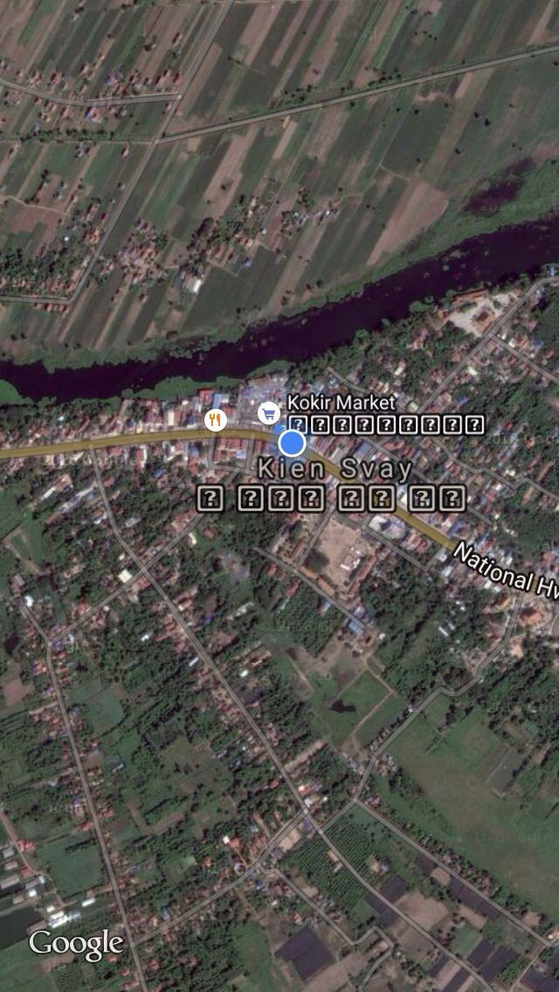
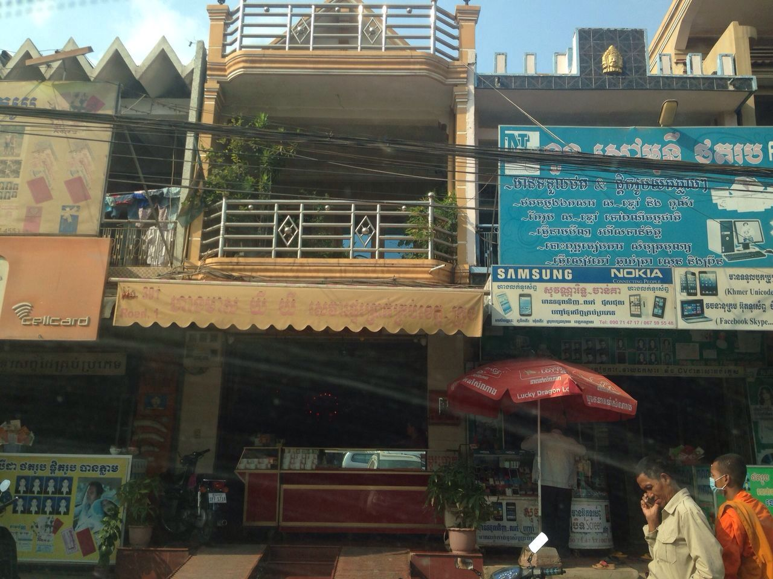
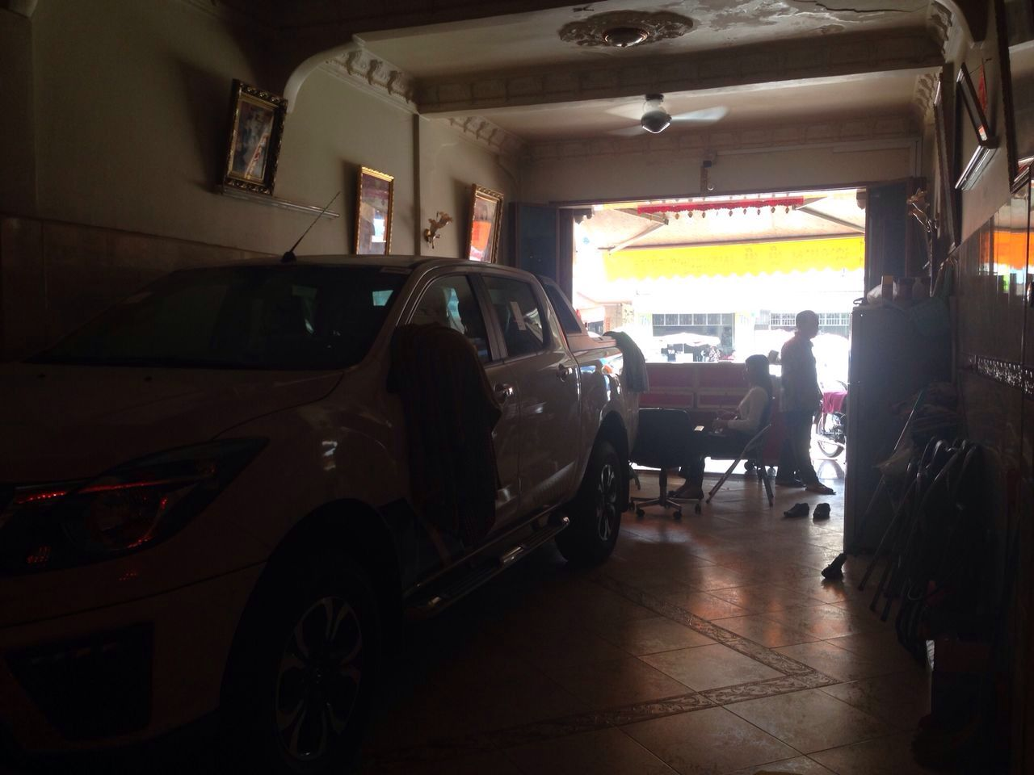

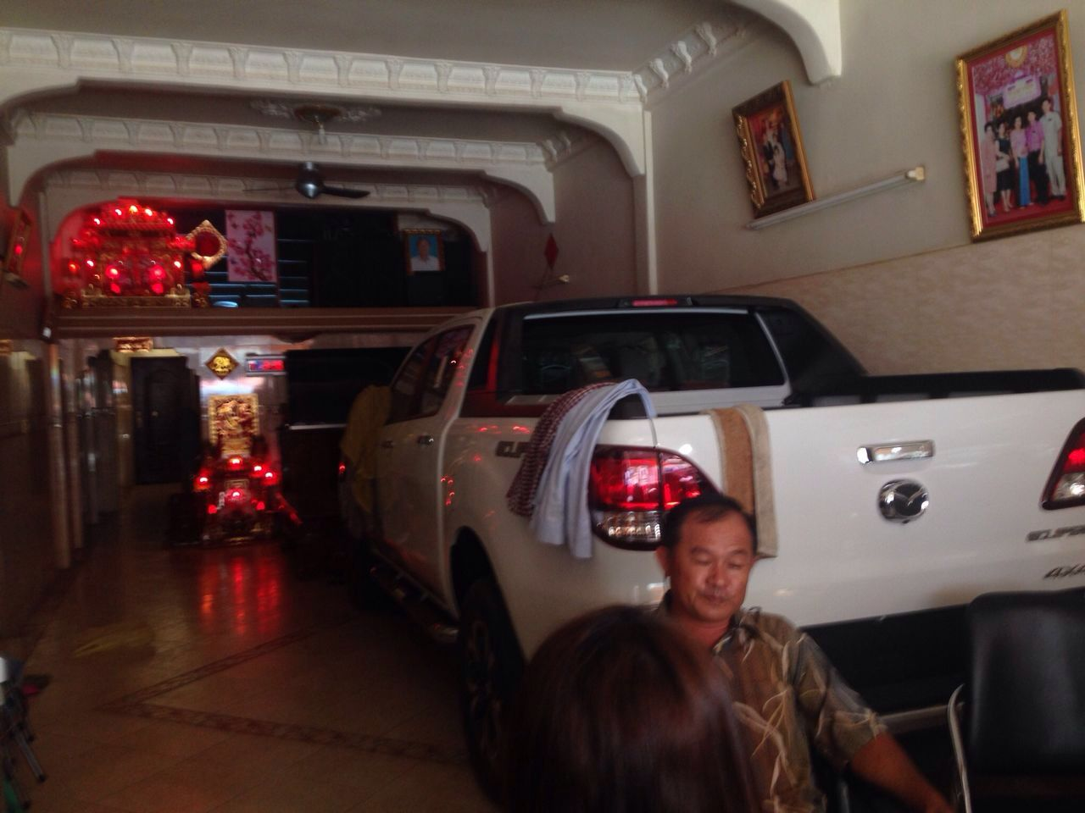

Property charged 2: Vacant Land (11,592sqm)
Address: National Road No. 1, Dey Eth Kohpos Village, Dey Eth Commune, Kean Svay District, Kandal Province.

